Query Folding and Native Query

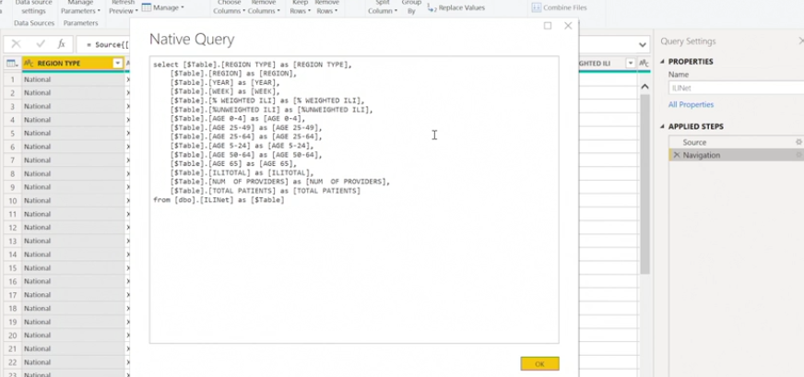

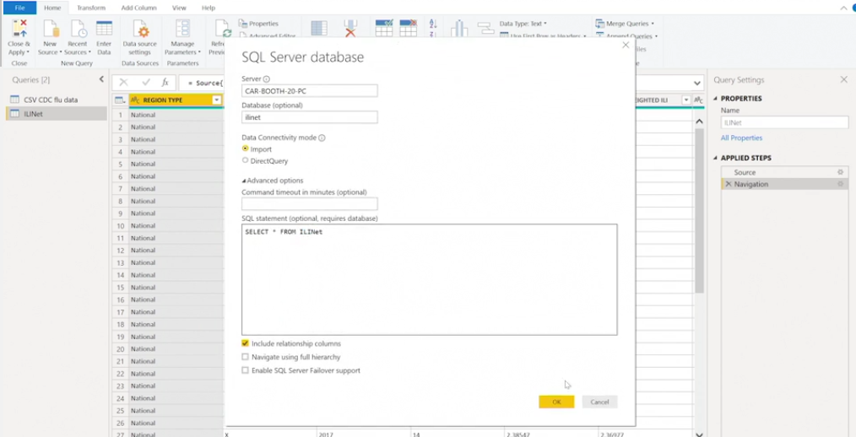

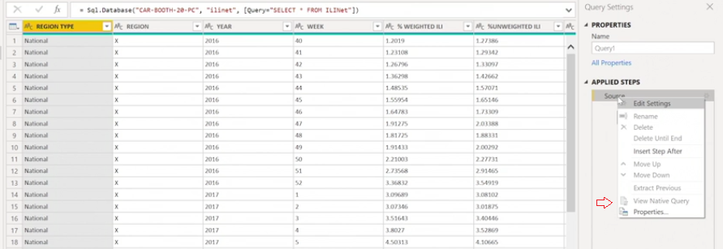

Connecting with Rest API

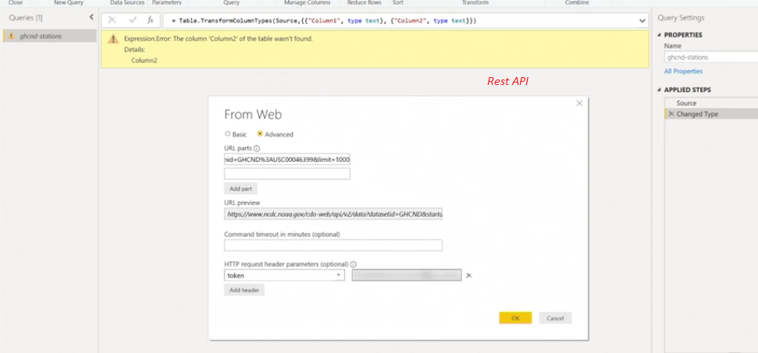

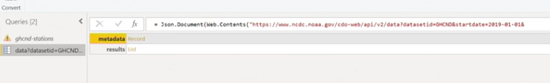

The GET request in a REST API connection allows you to do what?

It is an HTTP request that allows you to query your data through the REST API architecture.

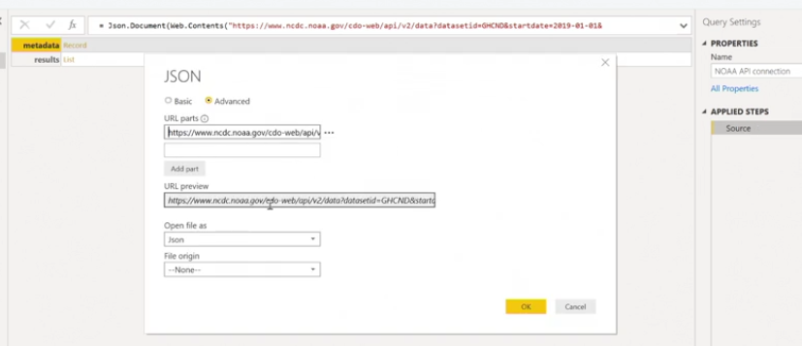

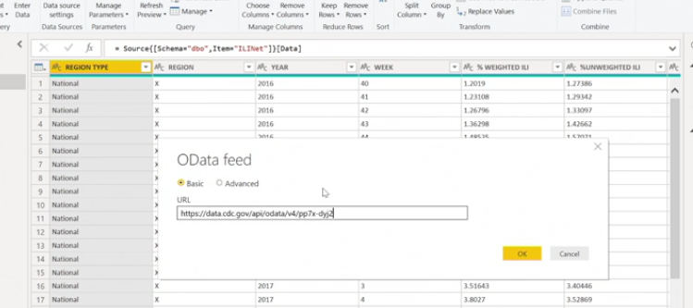

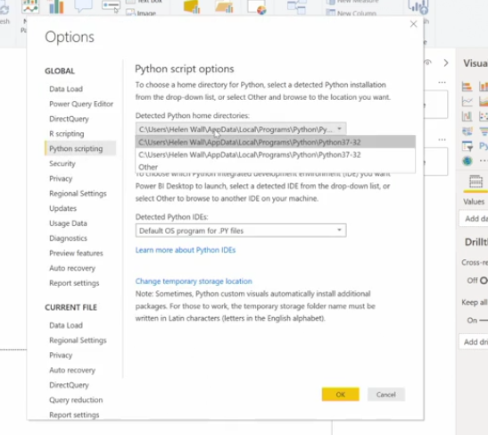

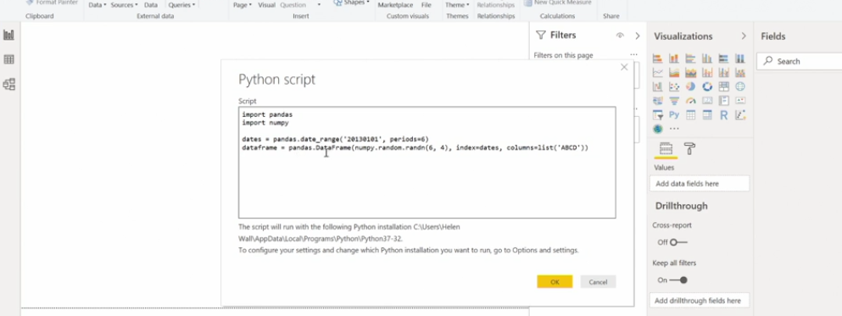

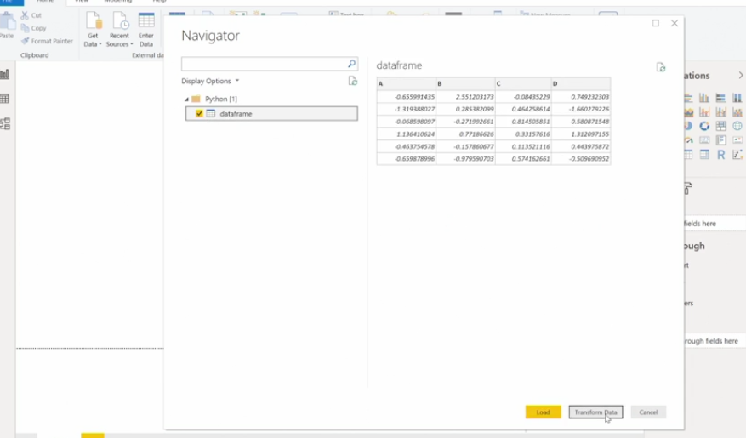

**Data Transformation : Cleaning**

**Leveraging Metadata**

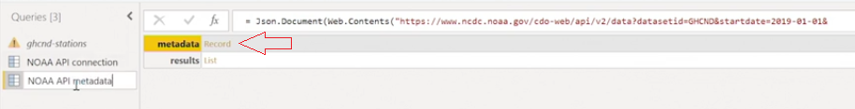

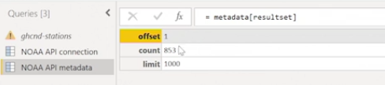

**Split column**

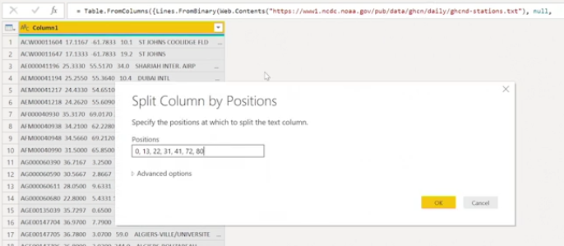

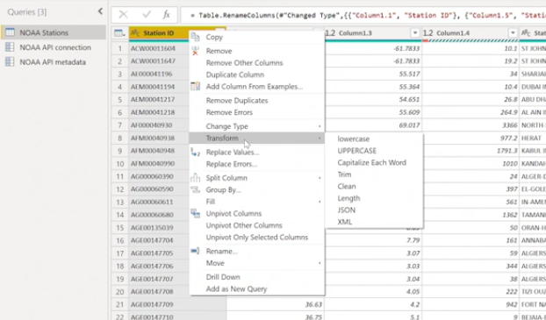

Transforming numeric Fields: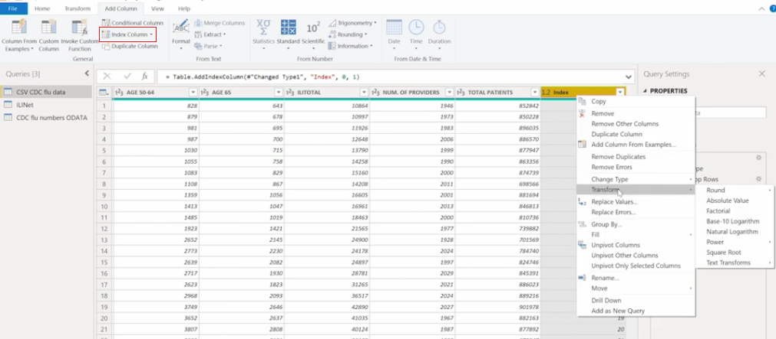

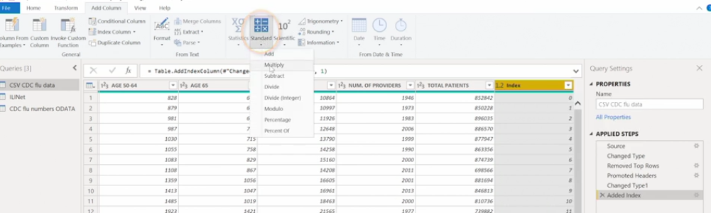

Removing / Replacing Error: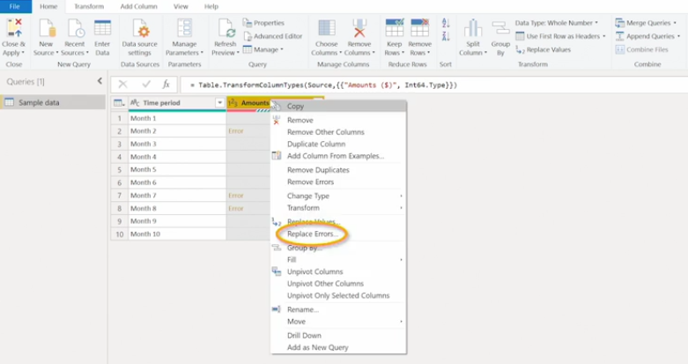

Remove Duplicate:

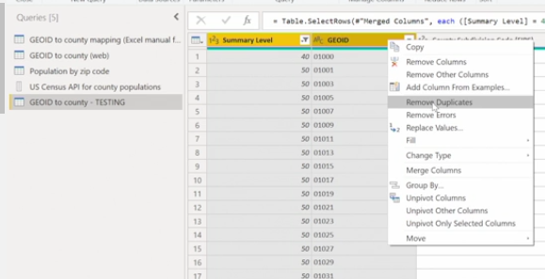

**Data Transformation : Integration**

Power Query Objects:

* tables
* Lists - column in table
* Records - row in a table
* Values
* Binaries
* Functions
* Errors
* parameters

Table

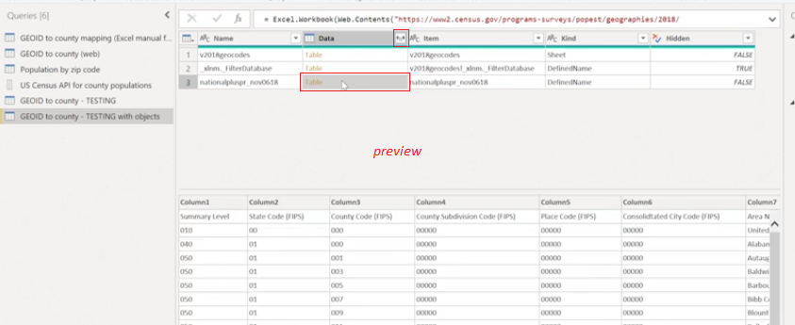

List

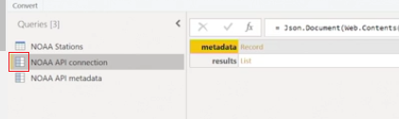

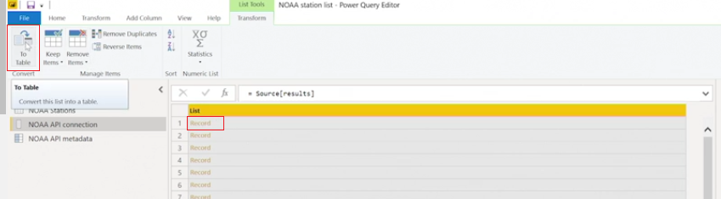

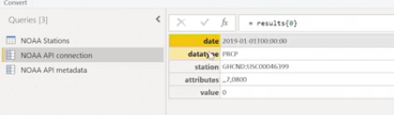

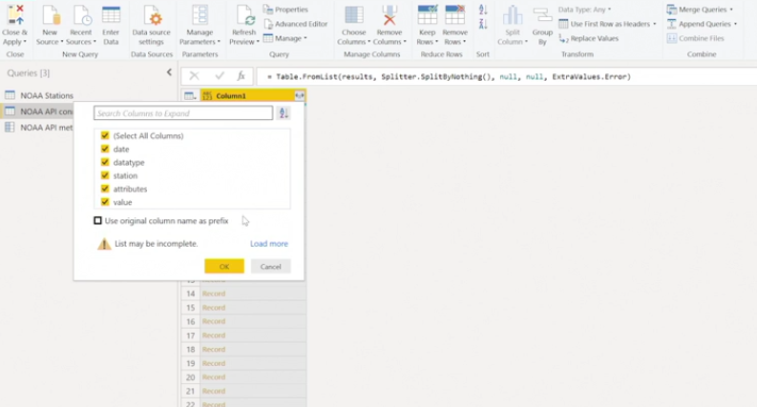

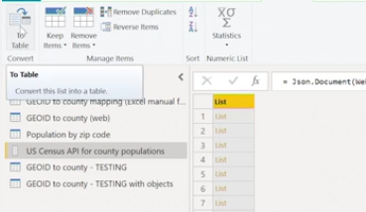

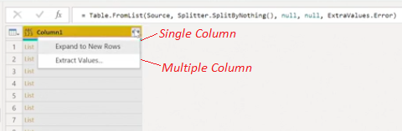

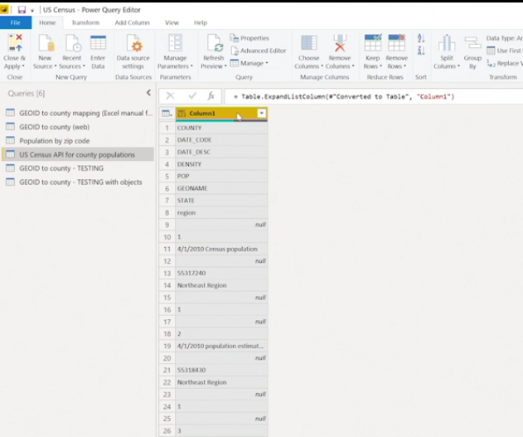

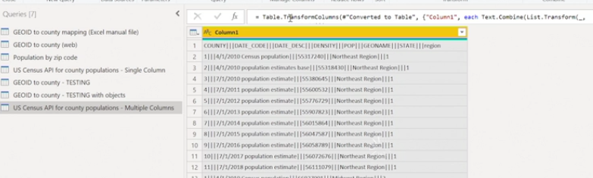

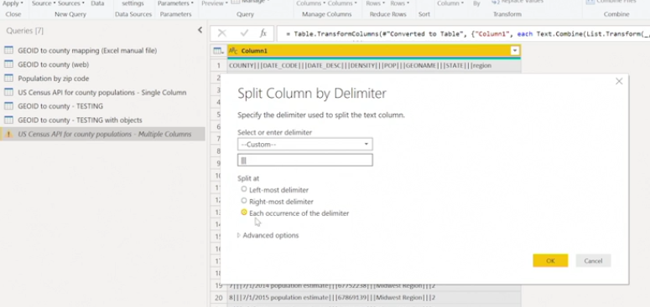

Binary Objects

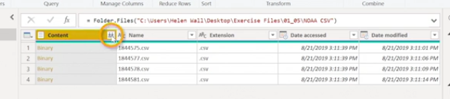

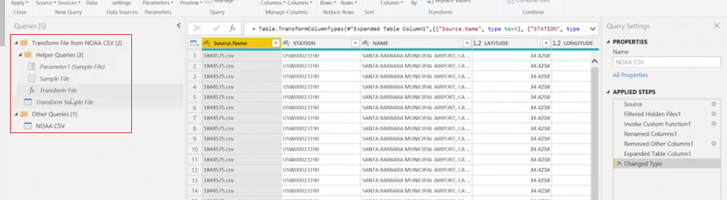

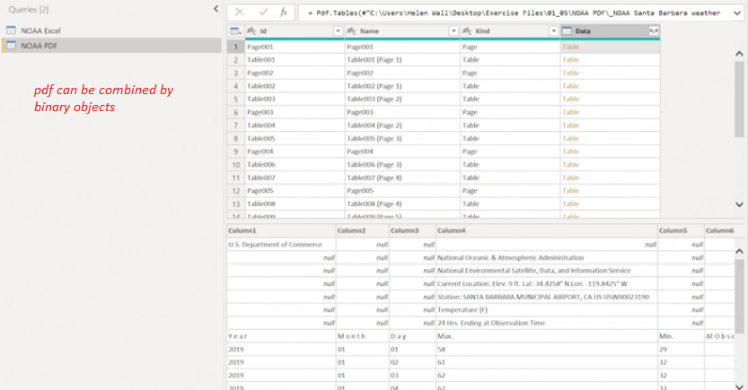

Grouping Data / Pivoting

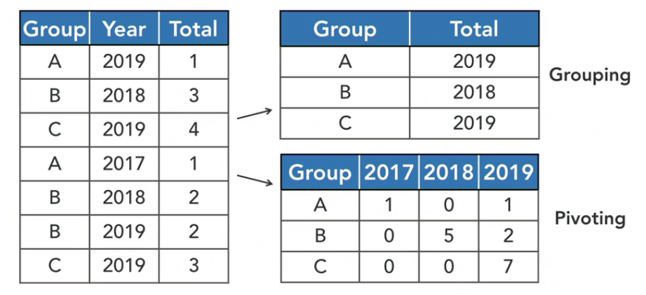

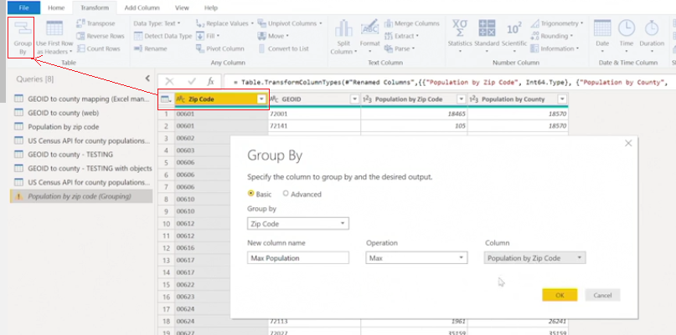

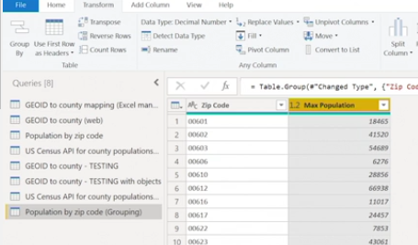

Let's say you have a theoretical data table containing three columns: purchase date, location, and amount. You want to create a new data table that groups the total amount together by the purchase date and location, which are still their own columns. How can you do this using the grouping functionality?

Select the Advanced Options and include both columns as categories to group the aggregated sum of the amounts by.

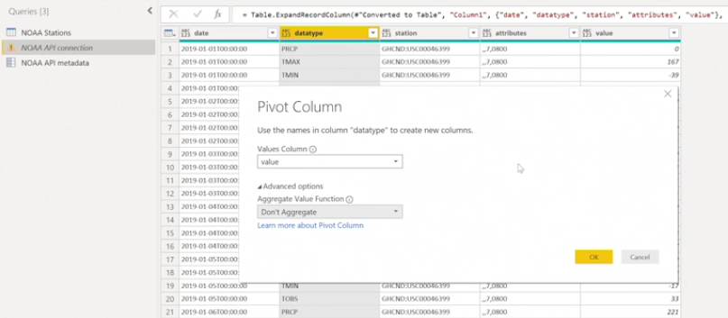

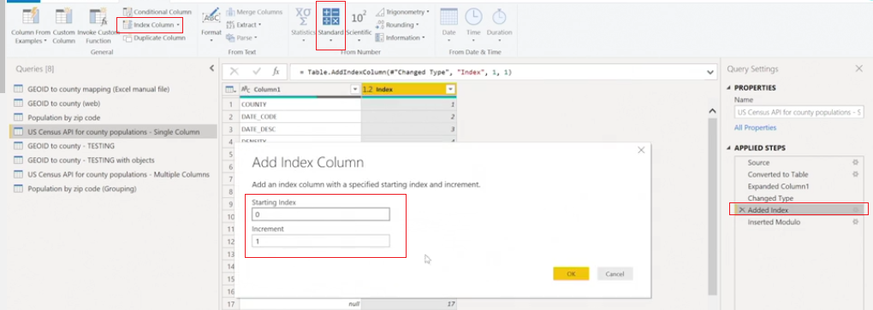

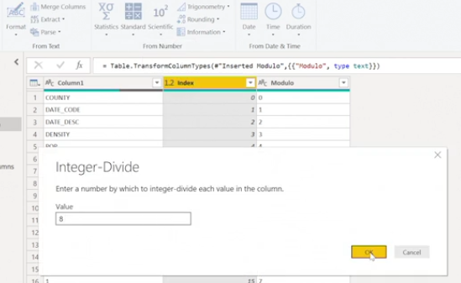

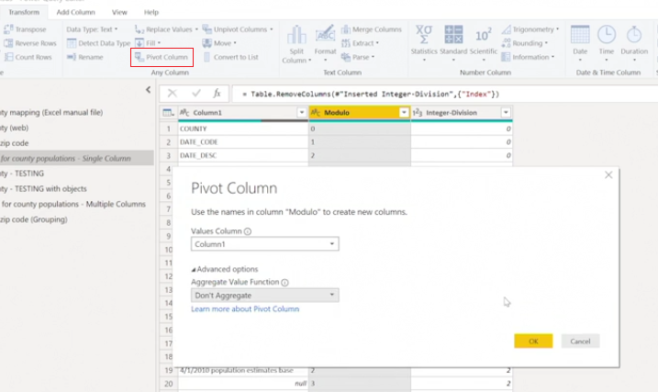

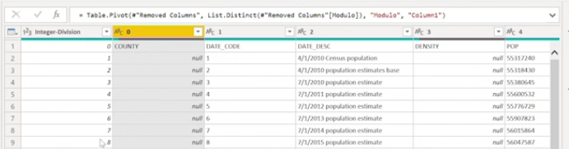

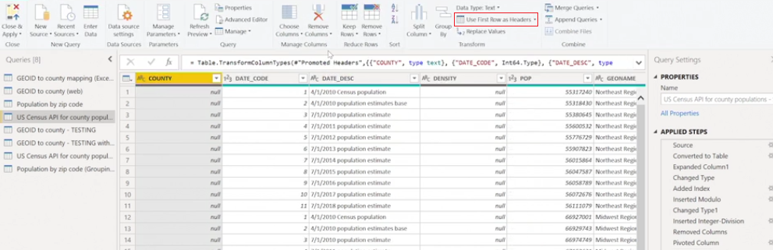

Transpose

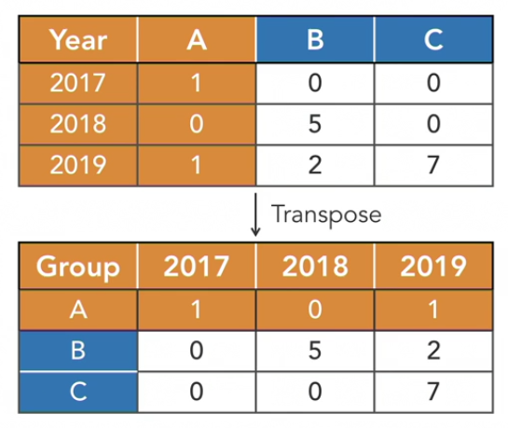

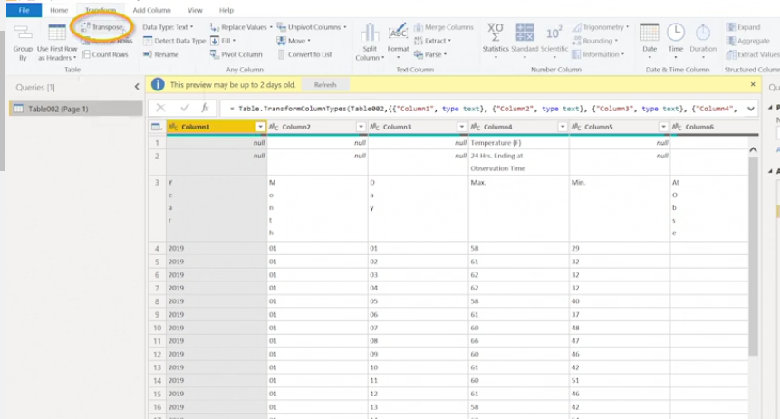

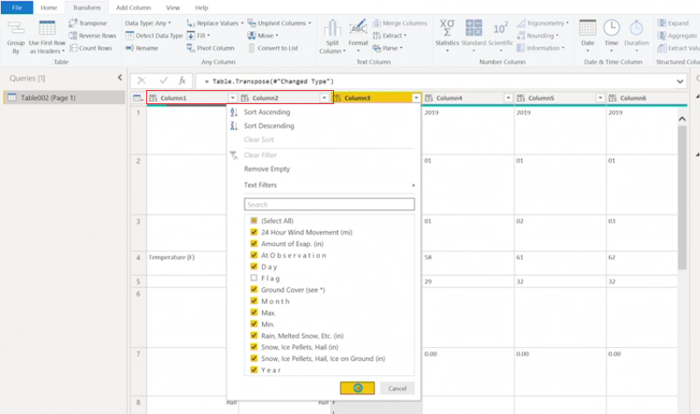

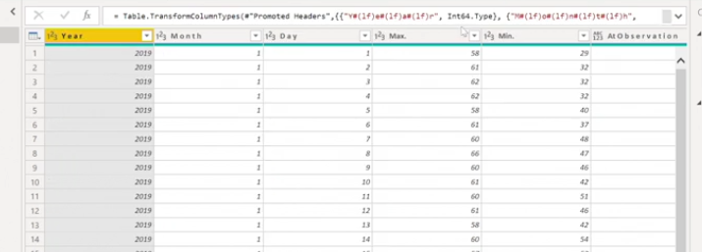

Unpivot

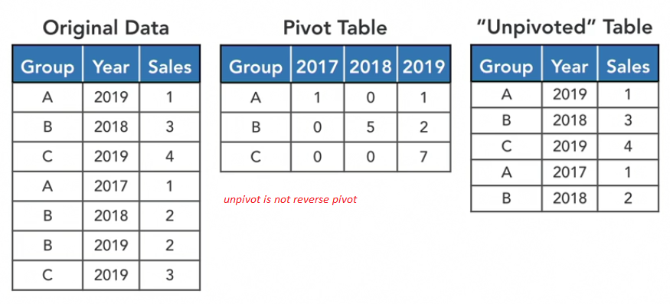

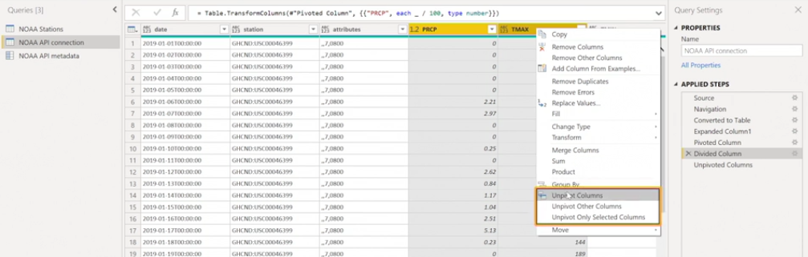

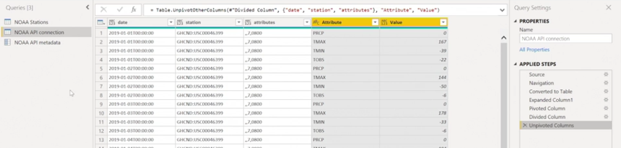

Accessing Native Query - Query folding

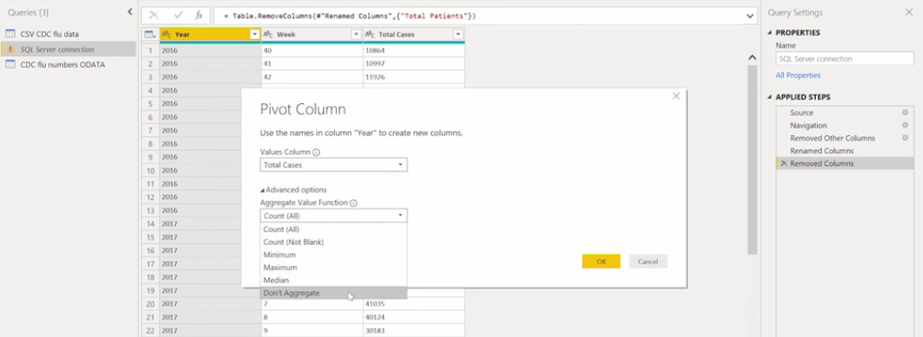

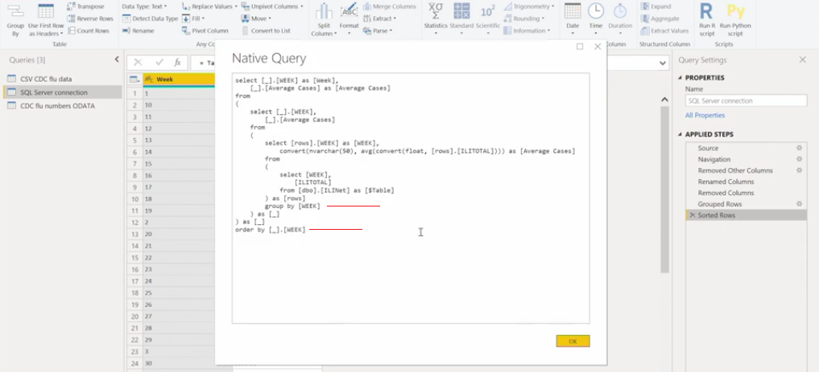

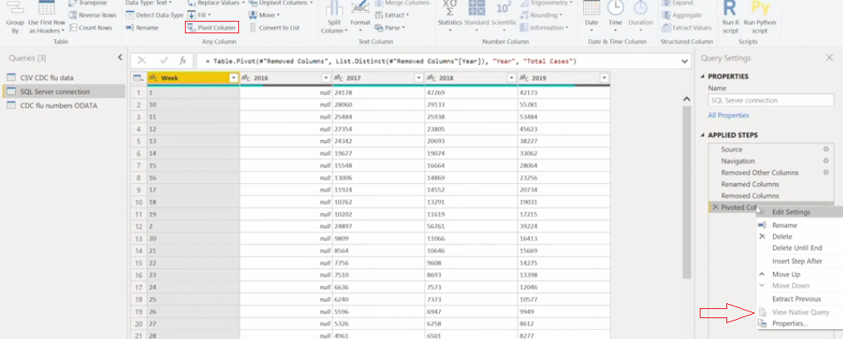

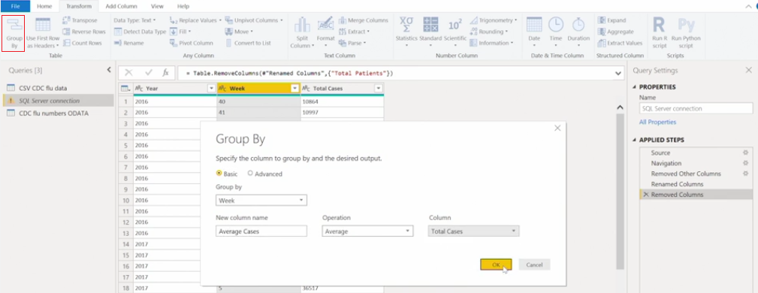

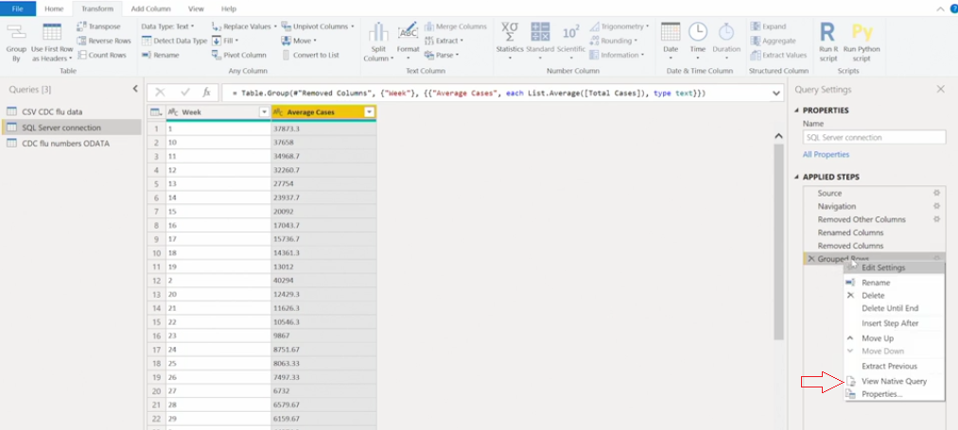

Transforming Data: Enrichment

Leveraging Text Formulas

|  |  |
| --- | --- |
| **Excel Formula** | **Power Query Formula** |
| Not case Sensitive | Case Sensitive |
| Base 1 | Base 0 |
| Implicit Data conversion | Strict Data Type |

|  |  |
| --- | --- |
| **Excel Formula** | **Power Query Formula** |
| LEFT | Text.Start |
| RIGHT | Text.End |
| LEN | Text.Length |
| FIND | Text.PositionOf |
| MID | Text.Range |

Converting Data Types

|  |  |
| --- | --- |
| **Other Types to Text** | **Text to other Types** |
| Date.ToText | Date.FromText |
| Time.ToText | Time.FromText |
| Number.ToText | Duration.FromText |
|  | Number.FromText |

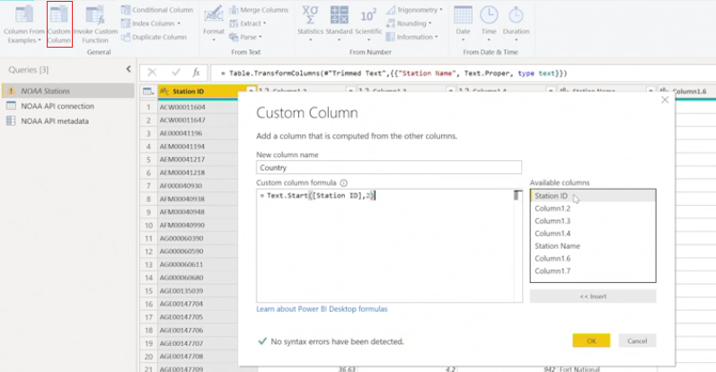

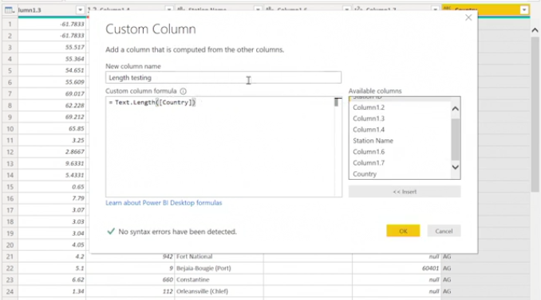

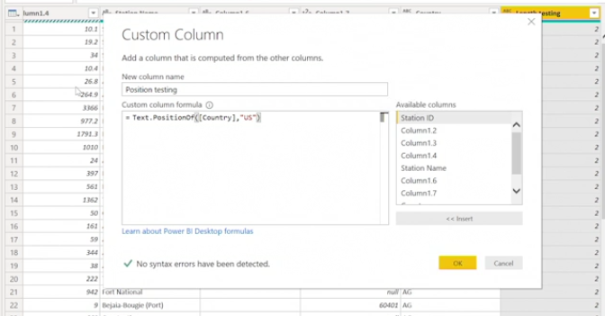

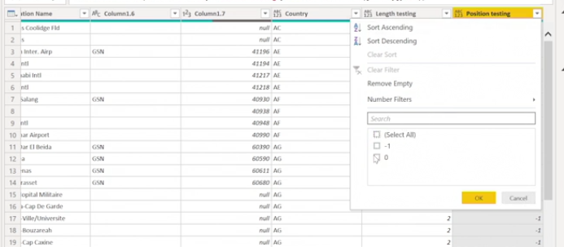

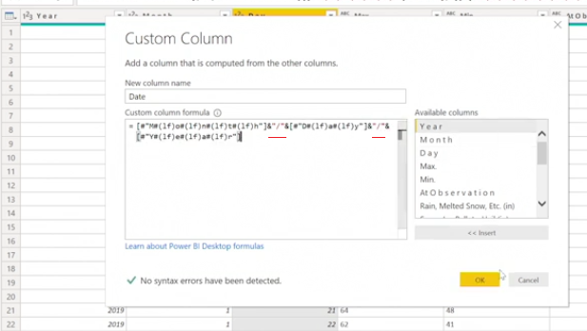

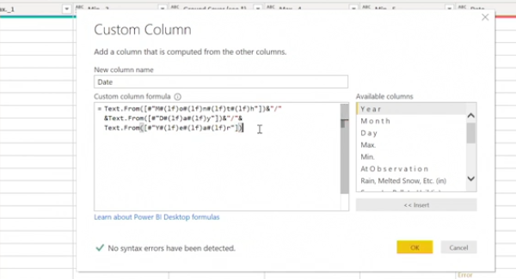

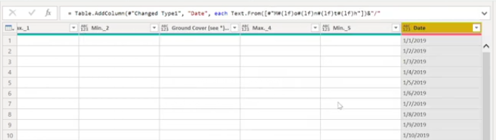

Conditional Functions:

if [Column1] = 1:

then "Result 1"

else if [Column2] = "A":

then "Result 2"

else if [Column3] = "B":

then "Result 3"

...

else [Column 2]

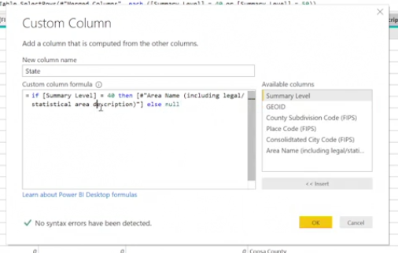

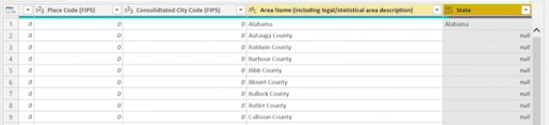

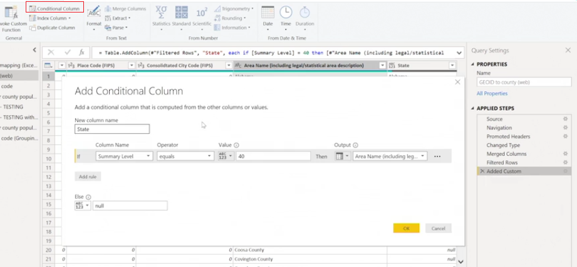

Fill up or Down Columns

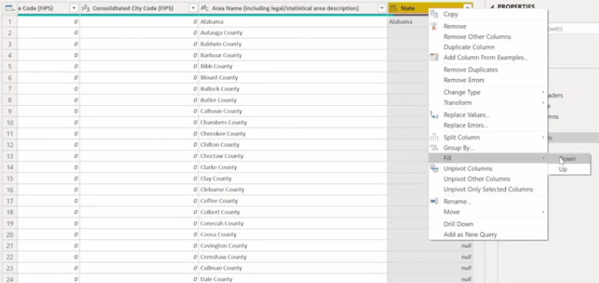

Leveraging Date Formulas

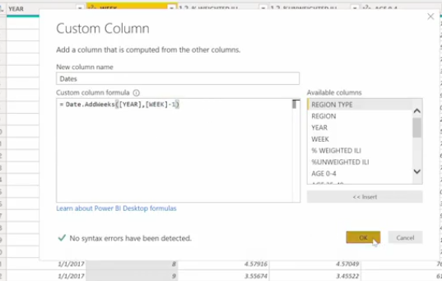

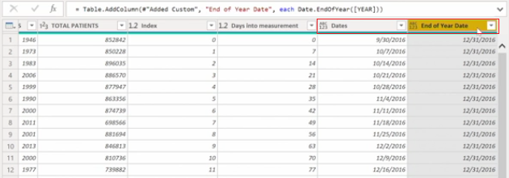

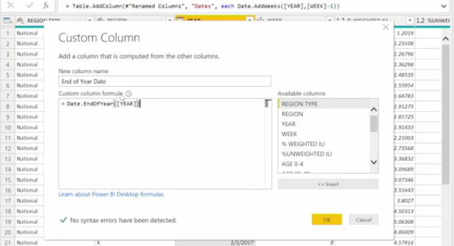

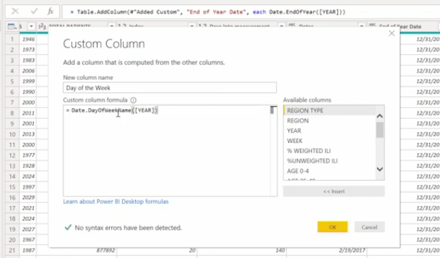

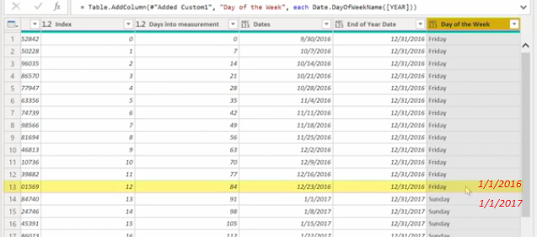

Combining Binary Files with Formulas

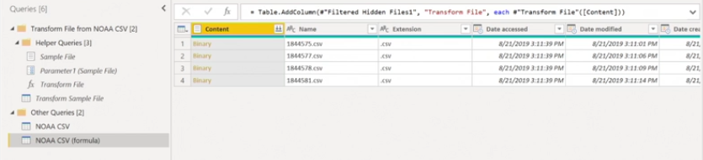

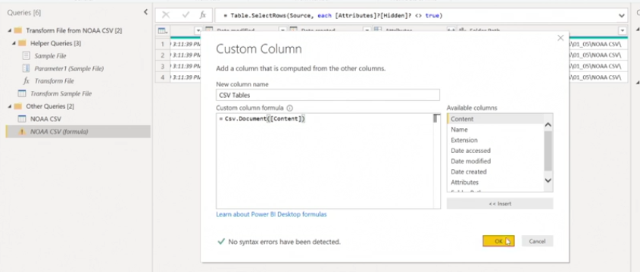

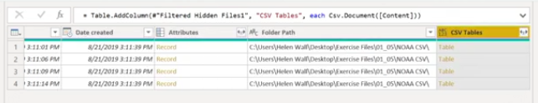

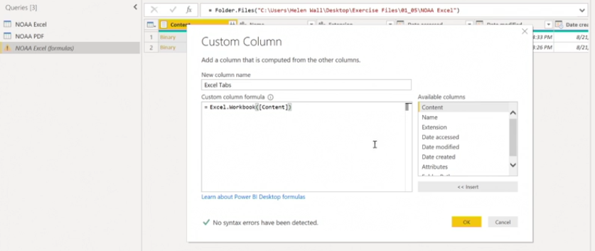

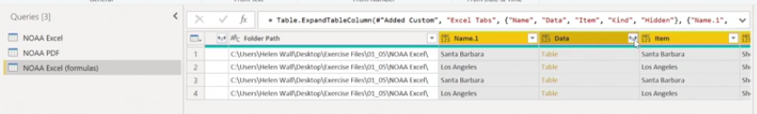

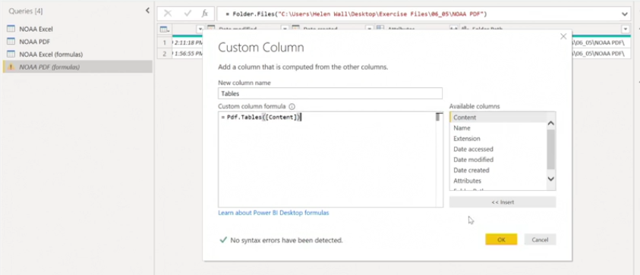

Accessing Native Query in enrichment

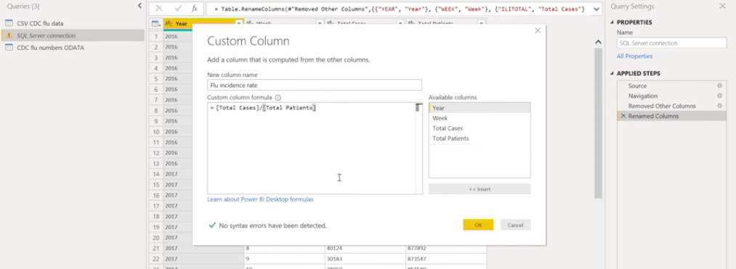

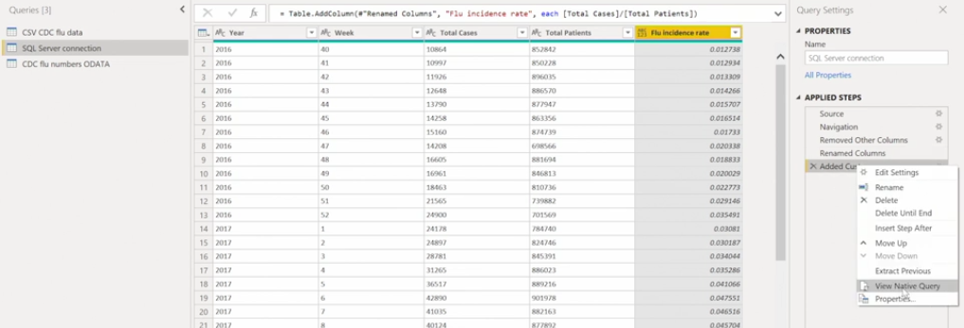

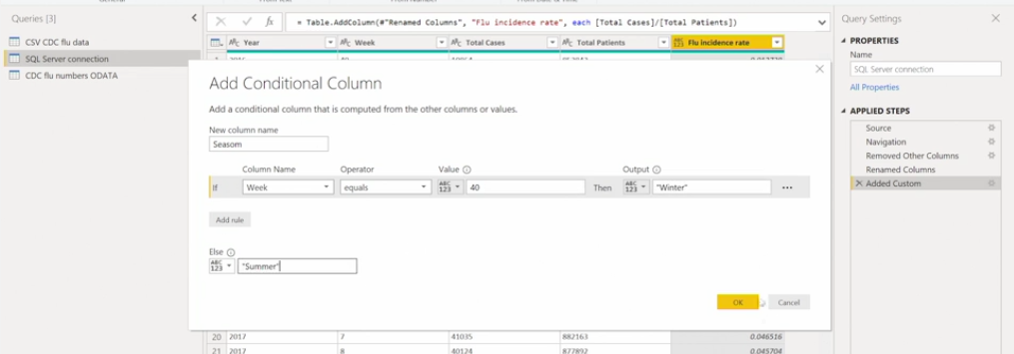

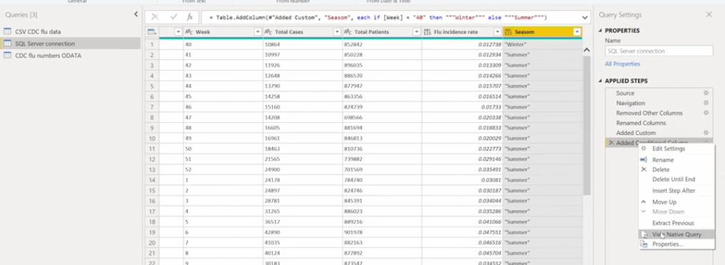

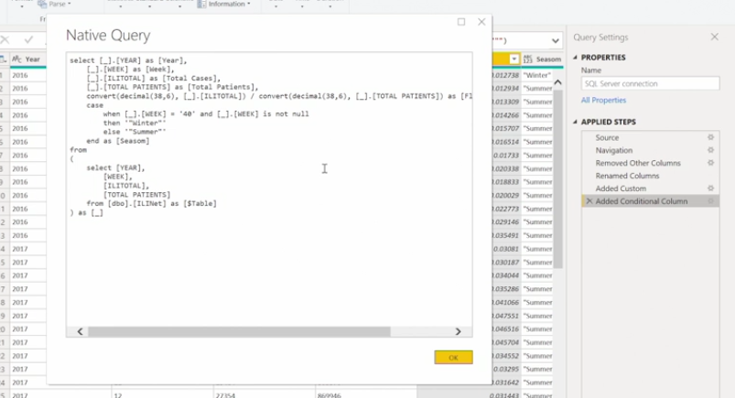

**Someone sent you an entire year of data as 12 months of Excel files with several tabs in them, but you only want one tab from each Excel file. What is the best approach to combine them in the query editor?**

First set up a function to read the tabs within each binary object (the Excel workbooks) as table objects, then combine these table objects into a single dataset.

**If you find that the fill down option does not work as anticipated on the target column, what are some triage options to get it to work?**

Isolate the nulls in either the column to fill down or create a new column to put the values to fill down and the null values in the other rows.